# CMR Design Document

## Class Diagram

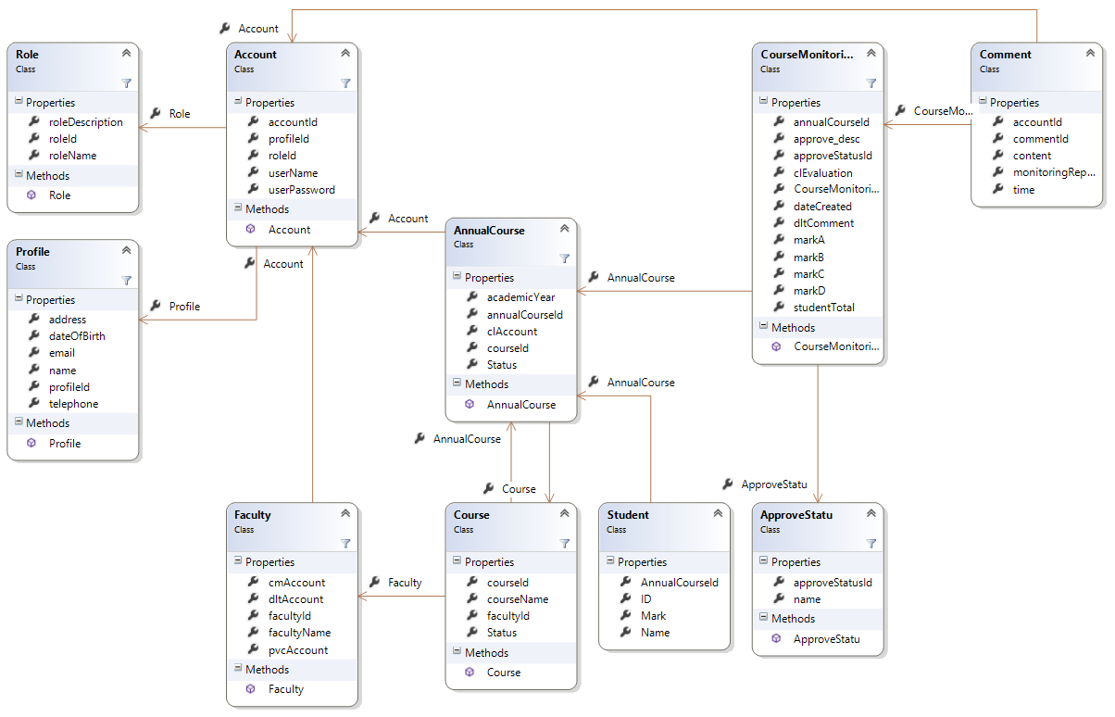

## User-case

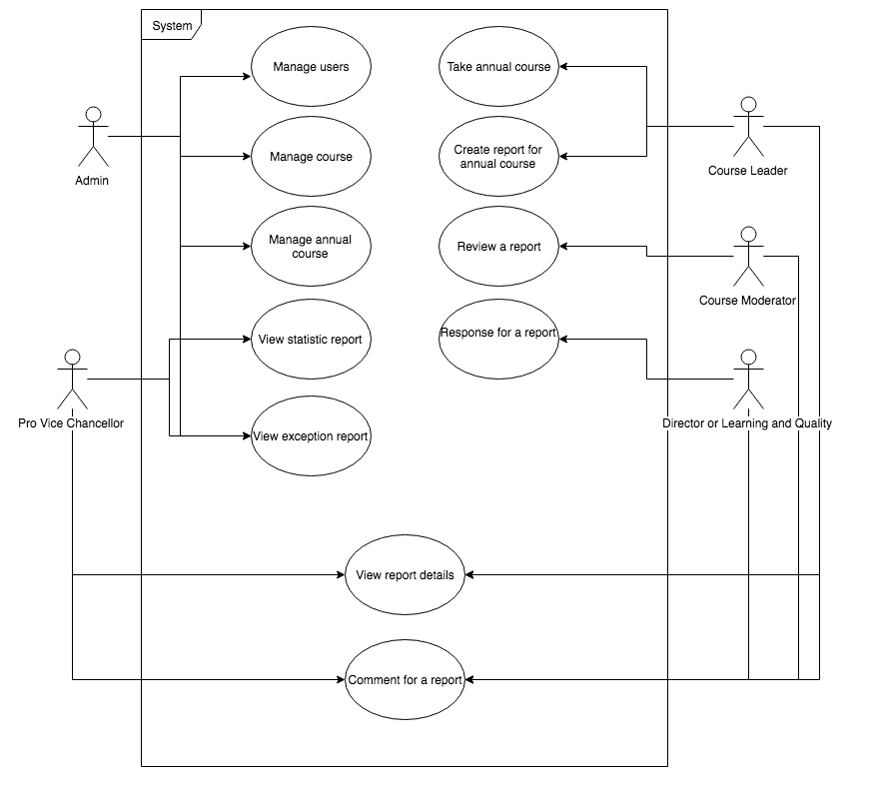

Figure 1. System use-case

|  |  |
| --- | --- |
| User case | Manage users |
| Actor | Admin |
| Pre-condition | Logged into system |
| Scenario | 1) Create new user account by clicking “New Account” button 2) Edit user profile by clicking “Edit” button 3) View user profile by clicking “View” button  4) View list of user by clicking “View user list” link |
| Post-condition | Account details will be reflected to database and current system and list account will be listed |

|  |  |
| --- | --- |
| User case | Manage course |
| Actor | Admin |
| Pre-condition | Logged into system |
| Scenario | 1) Create new course  2) Edit course details  3) View course details  4) View list of course |
| Post-condition | Course details will be reflected to database and current system and list of course will be listed |

|  |  |
| --- | --- |
| User case | Manage annual course |
| Actor | Admin |
| Pre-condition | Logged into system |
| Scenario | 1) Create new annual course 2) Edit annual course details  3) View annual course details  4) View list of annual course |
| Post-condition | Annual course will be reflected to database and current system and list of annual course will be listed |

|  |  |
| --- | --- |
| User case | View statistic report |
| Actor | Admin, Pro Vice Chancellor |
| Pre-condition | 1) Logged into system  2) Report data is existed |
| Scenario | Click “View Statistic Report” to show details about report. |
| Post-condition | The report show how many report is pending, waiting, approved, rejected for every year in Chart Display or Numeric Data |

|  |  |
| --- | --- |
| User case | View exception report |
| Actor | Admin, Pro Vice Chancellor |
| Pre-condition | 1) Logged into system  2) Report data is existed |
| Scenario | Click “View Exception Report” to show details about report. |
| Post-condition | The report show how many report is pending, not responded for every year in Chart Display or Numeric Data |

|  |  |
| --- | --- |
| User case | Take annual course |
| Actor | Course Leader |
| Pre-condition | 1) Logged into system  2) Has at least one available annual course |
| Scenario | 1) Click “View all available annual course”  2) Click “Take” button to take annual course |
| Post-condition | List of annual course of Course Leader is updated |

|  |  |
| --- | --- |
| User case | Create report for annual course |
| Actor | Course Leader |
| Pre-condition | 1) Logged into system  2) Has at least one taken annual course |
| Scenario | 1) Click “View all annual course” link  2) Click “Report” button for one annual course  3) Enter evaluation  4) Tick/Untick option which specify whether want to send Course Moderator immediately or not |
| Post-condition | 1) If “Send to Course Moderator” is ticked, an email will send to Course Moderator’s email, and that report will be marked as “Waiting”  2) If “Send to Course Moderator” isn’t ticked, that report will be marked as “Pending” |

|  |  |
| --- | --- |
| User case | Review a report |
| Actor | Course Moderator |
| Pre-condition | 1) Logged into system  2) Has at least one waiting report |
| Scenario | 1) Click “View all report” to see all waiting reports  2) Choose one report 3) Click to “Action” button and choose “Reject” or “Approve” option |
| Post-condition | 1) If reject, a report will be sent back to Course Leader for updating and send email to them. A report will be marked as “Rejected”  2) If approve, a report will marked as “Approved” and send email to Course Leader, Director of Learning and Quality and Pro Vice Chancellor. |

|  |  |
| --- | --- |
| User case | Response for a report |
| Actor | Director of Learning and Quality |
| Pre-condition | 1) Logged into system  2) Has at least one approved report |
| Scenario | 1) Click “View all report” to see all approved reports  2) Choose one report 3) Click to “Action” button and enter a response text |
| Post-condition | A report will be responded and reflect to database |

|  |  |
| --- | --- |
| User case | View report details |
| Actor | Course Leader, Course Moderator, Director of Learning and Quality, Pro Vice Chancellor |
| Pre-condition | 1) Logged into system  2) Has at least a report to see |
| Scenario | 1) Enter list of report screen  2) Click on an report to view details |
| Post-condition | The details of that report will be shown |

|  |  |
| --- | --- |
| User case | Comment for a report |
| Actor | Course Leader, Course Moderator, Director of Learning and Quality, Pro Vice Chancellor |
| Pre-condition | 1) Logged into system  2) Has at lease a report to comment |
| Scenario | 1) Go to Report Details screen  2) Type text on Comment field and push “Enter” |
| Post-condition | List of comment of that report will be updated |

## Activity Diagram

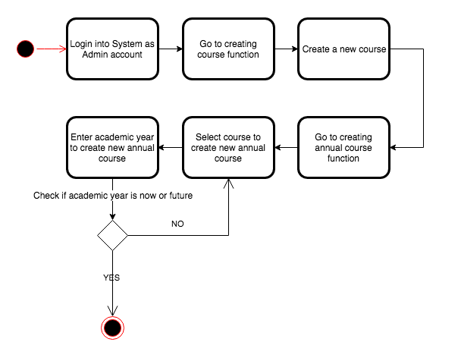

Figure 2 – Create Course and Annual Course

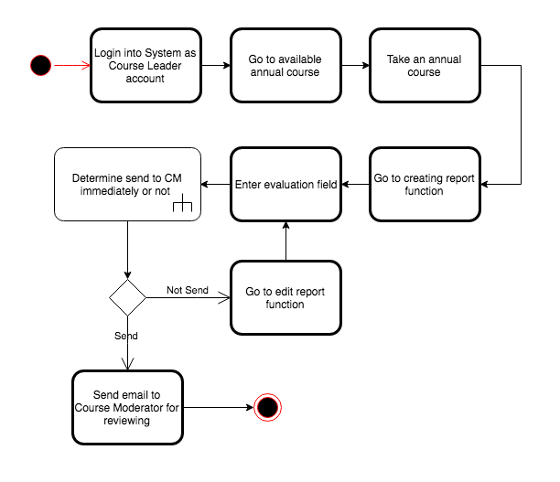

Figure 3 – Create report for an annual course

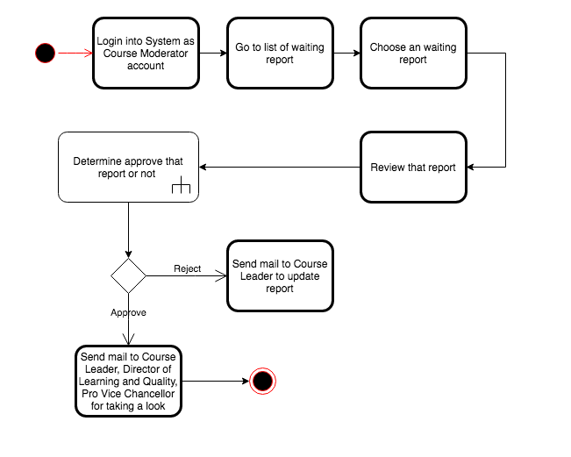

Figure 4 – Reviewing a report sent from Course Leader

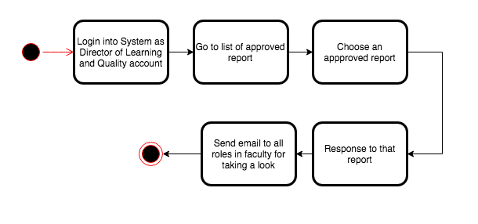

Figure 5 – Responding a report approved from Course Moderator